Editors Comments:

Q: In the sequence (12,23,31,13,32,21) I expect that n is 3 and that the formula (1) should give me this sequence if I let i (the strip number) go from 1 to 6. In that case n,k should have been x,y but what is R and why say R=1 on top?

- In a similar way I expected formula (2) to give me i (the strip number) given x and y and that the first and last line is used for the first and last form. In that case x=3 and y=1 should give i=3 using the middle expression but it does not. I find this interpretation reasonable reading the text carefully. Please modify the text so that it is easier to understand and that a simple check gives the correct result.

A:

I’m sorry that the tables were for the last version of encoding and decoding method, but the formulas were for the latest methods. That’s why you failed to decode the correct results of the rule in the table. The tables for the latest version are shown in Table. 1 and Table. 2, which are given in the form of pictures in the attachment for ease of reading. In the latest reversion, the tables have been modified.

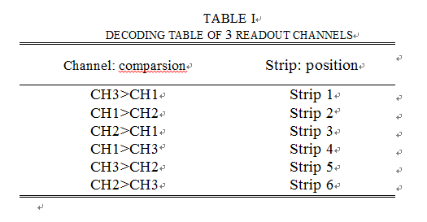

Fig. 1. Decoding table of 3 readout channels

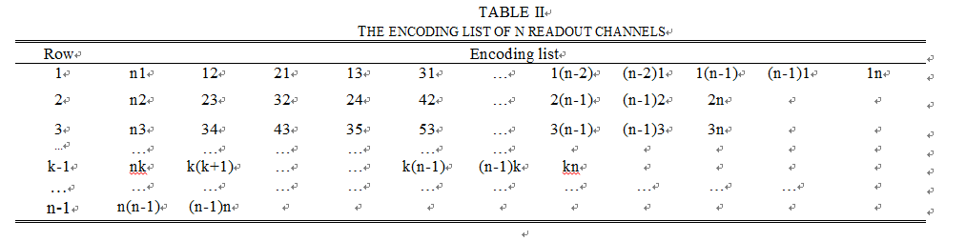

Fig. 2. The encoding list of n readout channels

If n = 3, for example, the encoded sequence is (31,12,21,13,32,23), which is shown in table 1 and table 2. The encoding formula and decoding formula are shown in Fig. 3 and Fig. 4.

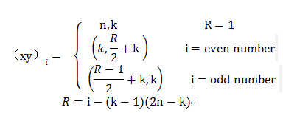

Fig. 3. Encoding formula

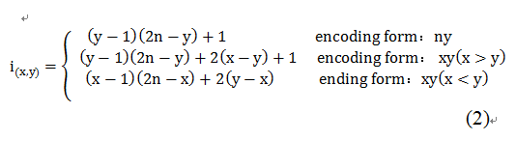

Fig. 4. Decoding formula

According to encoding formula in Fig. 3, k means the No. of row and R is a temporary variable. In this case of n = 3, k =1 and 2. When k = 1, R = i. If i (the strip number) increase from 1 to 4, the encoded answer of sequence is (31, 12,21,13). When k = 2, R = i – 4. The encoding answer of sequence is (32,23) as i increases from 5 to 6, according to encoding formula. The encoded sequence from table is combined by the 2 sequences from formula. The decoding formula is able to turn this sequence to the strip number correctly.

Q:

Fig 5. did not come through, and therefore the treatment of signals with a width larger

than the anode strip pitch in to clear. I don't understand the essence of group A, B and C.

A:

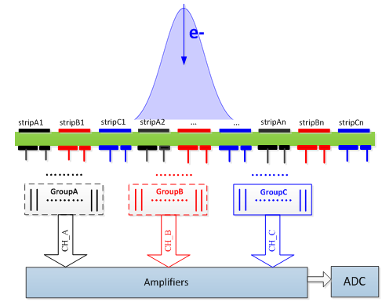

Fig. 5. Schematic of packet coding techniques

If the width of input charge signal is narrower than the anode strip pitch, there is no need to use Packet Coding technique. But, as the Fig. 5 shows, in most cases, the input signal has a width larger than the anode strip pitch, which means the signal will hit more than one strip. Since the bases of this encoding method is the assumption that only one strip is hit, if the adjacent anode strips are hit at the same time, the decoded answer will have faults according to decoding formula. (Because more than 2 channels will have effective responses) The Packet Coding technique is to separate adjacent strips into different groups in order to ensure that, in every group, only one strip is hit at the same time. The essence of group A, B and C is that each group encodes and decodes independently. By selecting the appropriate strip pitch and number of groups, the adjacent strips of same group will not be hit when an event with a certain width comes.

Q:

Figs 3 and 4 are not discussed. I don't see why one has a signal ratio 26/70 for a induced strip width ratio of 5. I can't read the horizontal axis of Fig 4, and it is not clear which signals are displayed.

A:

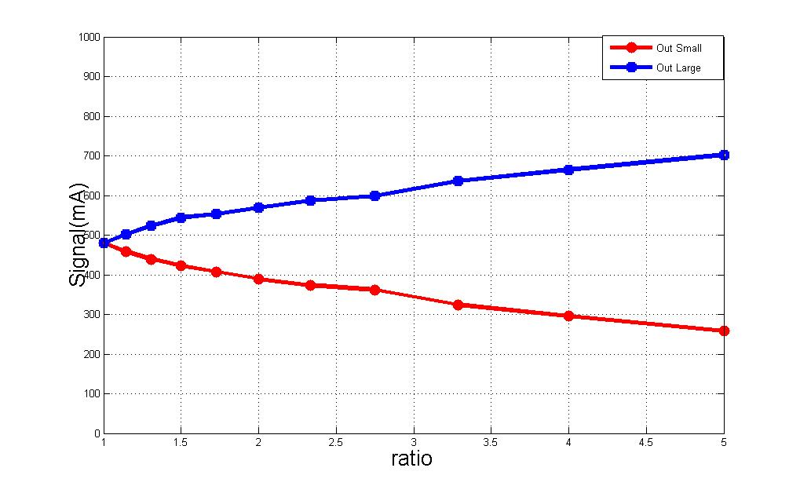

Fig. 6. The output signals of wide strip and narrow strip under different width ratio

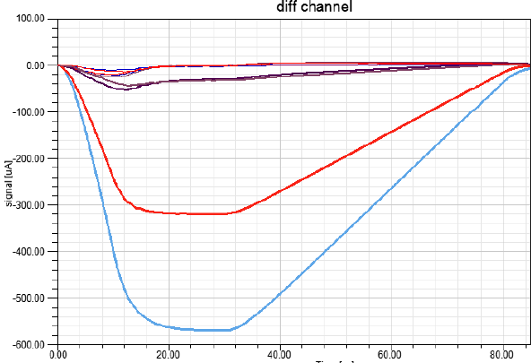

Fig. 7. Output signal of all electronic channels when ratio is 2:1

We can see that every anode strip has two induced strips from the previous article. One assumption of this method is that two induced strips get different induced charge, which means the width of two induced strips are different and the wider strip gets more charge. In order to optimize the width’s ratio of the two induced strips of one anode strip, we did many simulations with ANSYS’s software Designer and SIwave. During the simulation, a fixed current of 1 mA flowed through the anode strip. By observing the current on the two induced strips, we could optimize the ratio of the two induced strips. In Fig. 6, we changed the width’s ratio of the two induced strips and recorded the current on them. And we got the result that when the width’s ratio was 5:1, the induced current on these two strips were 700 uA and 260 uA.

We did another simulation that when the two induced strips width’s ratio was 2:1, the outputs of all the induced strips were recorded and drawn on the Fig. 7. The input was a negative current pulse with amplitude of 1 mA on one anode strip. We could see that not only the two induced strips of the anode strip had signals, but also the adjacent induced strips had a small pulse. In this condition when the ratio was 2, the largest signal had enough difference from the second largest signal. The second largest signal could be distinguished easily from crosstalk and noise. As a result, we took 2 as the ratio of the two induced strips.

Q:

A:

